QTC
QUIXOTIC TRADING ORGANIZATION
Technical Whitepaper
Automated Trading Protocol for the Qubic Network
Version 1.5
March 2026
Project Links
Discord: https://discord.gg/2NGfYds2Pm
Twitter: https://x.com/birb_lester

IMPORTANT DISCLAIMER
RISK WARNING: Cryptocurrency trading involves substantial risk of loss and is not suitable for every investor. The value of digital assets can fluctuate significantly, and past performance is not indicative of future results. QTC tokens represent participation in an automated trading service and do not constitute securities, financial instruments, or investment contracts.
DO YOUR OWN RESEARCH (DYOR): This whitepaper is for informational purposes only and does not constitute financial, investment, legal, or tax advice. You should conduct your own research and consult with qualified professionals before making any investment decisions. Never invest more than you can afford to lose.
NO GUARANTEES: This document does not guarantee profits, returns, or the success of the QTC project. Market conditions, technical challenges, regulatory changes, and unforeseen circumstances may adversely affect project performance. All projections and estimates are subject to change without notice.
NO REFUNDS: QTC token purchases are final and non-refundable. This is a service offering, not a product purchase. By participating in the ICO , you acknowledge and accept all associated risks.
REGULATORY CONSIDERATIONS: Cryptocurrency regulations vary by jurisdiction and are subject to change. It is your responsibility to ensure compliance with applicable laws in your region. This offering may not be available to residents of certain countries.

8. LEGAL DISCLAIMER & TERMS - Rementioned for Visibility

8.1 No Investment Advice
This whitepaper is provided for informational purposes only and does not constitute financial, investment, legal, or tax advice. You should not interpret any information contained herein as a solicitation to purchase QTC tokens or any other financial instruments. The information presented is not tailored to your specific financial situation, investment objectives, or risk tolerance.
Before making any investment decision, you must conduct your own due diligence and consult with qualified financial advisors, legal counsel, and tax professionals familiar with cryptocurrency investments and your specific jurisdiction's regulations.

8.2 Forward-Looking Statements
This whitepaper contains forward-looking statements regarding future events, projections, expectations, and plans. These statements are subject to significant risks, uncertainties, and assumptions that may cause actual results to differ materially from those expressed or implied. Forward-looking statements include but are not limited to:
- Projected trading bot performance and profitability
- Anticipated token buyback volumes and timing
- Development roadmap timelines and feature completion
- Market conditions and trading environment assumptions
- Expected regulatory treatment and compliance approaches
The QTC team undertakes no obligation to update forward-looking statements as circumstances change or new information becomes available. Do not place undue reliance on such statements.

8.3 No Guarantees or Representations
Quixotic Trading Organization makes no guarantees, warranties, or representations regarding:
- The profitability or performance of the trading bot under any market conditions
- The future value, liquidity, or marketability of QTC tokens
- The successful completion of all development roadmap items
- The continued availability of exchange APIs or trading infrastructure
- The accuracy, completeness, or reliability of information in this whitepaper
- The regulatory status or legal treatment of QTC in any jurisdiction

8.4 Regulatory Compliance
Cryptocurrency regulations vary significantly across jurisdictions and are subject to rapid change. It is solely your responsibility to determine whether your participation in the QTC project complies with applicable laws and regulations in your jurisdiction. The QTC project may not be available to residents of certain countries due to regulatory restrictions.
By acquiring QTC tokens, you represent and warrant that: (1) you have the legal capacity and authority to participate, (2) your participation does not violate any applicable laws or regulations, (3) you are not a resident of a prohibited jurisdiction, and (4) you understand and accept all associated risks.

8.5 Limitation of Liability
To the maximum extent permitted by applicable law, Quixotic Trading Organization, its developers, team members, advisors, and affiliates shall not be liable for any direct, indirect, incidental, special, consequential, or punitive damages arising from:
- Acquisition, holding, or disposal of QTC tokens
- Use of or reliance on information contained in this whitepaper
- Technical failures, security breaches, or operational disruptions
- Losses incurred through trading bot operations or market movements
- Changes in regulatory treatment or legal requirements
- Inability to complete planned development or operational objectives

8.6 Modification and Updates
Quixotic Trading Organization reserves the right to modify, update, or replace any aspect of this whitepaper, the project roadmap, tokenomics structure, or operational procedures at any time without prior notice. Such modifications may be necessary to address technical requirements, regulatory changes, market conditions, or other unforeseen circumstances.
Updated versions of this whitepaper will be published through official channels. Token holders are responsible for staying informed about project developments and updates.

8.7 Final Acknowledgment
BY ACQUIRING QTC TOKENS, YOU ACKNOWLEDGE THAT:
- You have read, understood, and agree to all terms and conditions outlined in this whitepaper
- You understand that cryptocurrency investments carry substantial risk of complete capital loss
- You have conducted your own independent research and due diligence
- You are investing only funds you can afford to lose completely
- You accept all risks associated with the project and will not hold the QTC team liable for any losses
- You understand that QTC tokens are non-refundable service utility tokens, not securities or investment contracts
- You have verified compliance with all applicable laws in your jurisdiction
REMEMBER: DO YOUR OWN RESEARCH. NEVER INVEST MORE THAN YOU CAN AFFORD TO LOSE.

***

1. EXECUTIVE SUMMARY
Quixotic Trading Organization (QTC) presents an innovative automated trading solution built specifically for the Qubic network ecosystem. Our proprietary algorithmic trading bot leverages advanced market sampling techniques and dynamic parameter adjustment to provide liquidity, facilitate efficient price discovery, and generate sustainable returns through strategic market-making operations.
The QTC protocol introduces a deflationary tokenomics model featuring a multi-phase ICO with progressive buyback mechanisms. Through systematic token burns and strategic liquidity provision, QTC aims to create long-term value for token holders while contributing to the overall health and stability of the Qubic trading ecosystem.

1.1 Key Features
- Adaptive Market Intelligence: Real-time market sampling and dynamic order adjustment based on volatility and trend analysis
- Multi-Layer Trading Architecture: Sophisticated buy-order stratification to capitalize on market dips and optimize entry points
- Deflationary Token Model: Systematic buyback and burn mechanism to reduce circulating supply over time
- Performance-Optimized Execution: Target profit margin of 0.90% per trade cycle (Note of exchange fees + profit loss at 0.05%)
- Transparent Fund Management: Multi-account architecture with clearly defined capital allocation across trading operations, reserves, and project development

1.2 Project Objectives
- Establish QTC as the premier automated liquidity provider for Qubic network assets
- Generate consistent returns through sophisticated algorithmic trading strategies
- Implement sustainable buyback mechanisms to create deflationary pressure on QTC token supply
- Foster community transparency through real-time fund tracking and operational updates on Discord
- Scale trading operations to maximize efficiency and capital utilization over time

2. INTRODUCTION

2.1 Market Context
The Qubic network represents an innovative blockchain ecosystem with unique computational capabilities and growing market demand for efficient trading infrastructure. As the ecosystem matures, there is an increasing need for sophisticated liquidity provision and market-making services that can adapt to varying market conditions.
Traditional manual trading approaches and static automated systems often fail to capitalize on rapid market movements or adequately manage risk during periods of high volatility. QTC addresses these limitations through a purpose-built algorithmic solution designed specifically for the characteristics of Qubic network assets.

2.2 The QTC Solution
QTC introduces a proprietary trading algorithm that has been rigorously developed and tested over several months. The system is entirely custom-built with parameters specifically optimized for Qubic network trading dynamics, combining real-time market data analysis with dynamic risk management to execute high-frequency trading strategies while maintaining capital preservation during adverse market conditions.

2.3 Technology Foundation
The QTC trading system is built on a robust technical architecture featuring:
- Custom-developed algorithm with proprietary market analysis techniques
- Real-time data sampling and processing capabilities
- Dynamic parameter adjustment based on market volatility and trend indicators
- Multi-layer order execution system for optimal market positioning
- Automated fund management across multiple operational accounts
- Integration with exchange APIs for seamless trade execution

3. TECHNICAL ARCHITECTURE

3.1 Trading Algorithm Overview
The QTC trading algorithm operates on a sophisticated market-sampling methodology that continuously analyzes price action, volume patterns, and volatility metrics to inform trading decisions. The system employs a multi-layered approach to order placement, enabling it to capture value across various market scenarios.

Core Algorithm Components
Market Data Sampling Engine: Continuously collects and processes tick-by-tick market data including price movements, order book depth, and trading volume. The sampling frequency adapts to market volatility, increasing during periods of rapid price movement.
Volatility Assessment Module: Calculates real-time volatility metrics to determine optimal trading intensity. During high-volatility periods, the system increases trading frequency and adjusts position sizes to capitalize on rapid price fluctuations while managing risk exposure.
Dynamic Order Sizing System: Automatically calculates optimal order sizes based on available capital, current market conditions, and risk parameters. Orders scale proportionally with available funds, ensuring efficient capital utilization.
Multi-Layer Buy Architecture: Implements multiple buy-order layers at strategic price intervals below current market price. This stratification ensures the system can acquire assets during price dips while maintaining adequate reserve capacity for deeper corrections.
Take-Profit Optimization: Each buy order is paired with a corresponding sell order targeting a 0.90% profit margin per trade ( Excluding exchange fees and Profit Loss at 0.05%). The system dynamically adjusts take-profit levels based on market momentum and liquidity conditions.

3.2 Trading Performance Characteristics

Optimal Market Conditions
The QTC algorithm performs optimally under the following market scenarios:
- High Volatility Periods: Rapid price movements create frequent trading opportunities, allowing the system to execute multiple profitable cycles within short timeframes
- Bull Market Conditions: Sustained upward trends enable profitable position accumulation with favorable exit opportunities
- Range-Bound Markets: Consistent oscillation within defined price ranges allows for predictable buy-low-sell-high execution

Challenging Market Conditions
The system faces performance constraints under prolonged bear market scenarios. During extended downtrends, the multi-layer buy architecture requires substantial reserves to maintain trading capacity at increasingly lower price levels. However, the system is designed to:
- Preserve capital through reduced position sizing during sustained downtrends
- Maintain long-term reserves to resume full trading capacity when market conditions improve
- Continue buyback operations using accumulated profits when market stabilizes or recovers

3.3 Fund Management Architecture
QTC employs a sophisticated multi-account structure to ensure operational efficiency, risk management, and transparency. Funds are segregated across four distinct accounts, each serving a specific operational purpose:
Account 1 - Primary Trading Operations: Contains the active trading capital and maintains optimal liquidity levels for immediate market execution. This account holds the primary reserves used for buy-order placement and maintains a target balance based on market conditions.
Account 2 - Strategic Reserves (Bear Market Buffer): Automatically accumulates stablecoin reserves (USDC) during profitable periods. These funds serve as a strategic buffer during prolonged bear markets, providing additional capital to maintain trading operations at lower price levels. Automated conversion to USDC occurs at market prices.
Account 3 - Profit Accumulation & Buyback Fund: Trading profits are automatically routed to this account and converted to Qubic at prevailing market rates. These funds are designated for QTC token buyback operations, creating consistent buying pressure and reducing circulating supply over time.
Account 4 - Project Development Reserve: Holds allocated funds for ongoing development, maintenance, infrastructure costs, and operational expenses. This account ensures the project's long-term sustainability and continuous improvement.

4. Initial Coin Offering (ICO) Structure (Updated version)
Token Ticker: QTC
Full Name: Quixotic Trading Organization
Network: Qubic
Total Supply: 110 619 667 655 QTC
Token Type: Service Token (not a security or investment contract)
After the project's launch, a series of major changes were implemented. To better manage these developments and enable the release of funds, the project entered an ICO phase as approved by a QIP. Additionally, 329,373,320,189 QTC tokens were burned to adjust the total supply, which was deemed too high.

ICO Phase | Tokens Available | Price | Buyback
Epoch 198 | 36,439,781,094 | 1 QUBIC | 2 QUBIC
Epoch 199 | 36,439,781,094 | 3 QUBIC | 4 QUBIC
Epoch 200 | 36,439,781,094 | 5 QUBIC | 6 QUBIC

Phase | Tokens Available
Initial Supply | 440 000 000 000
Burn Of Token Supply | -329 373 320 189
Burn Of Token  Trade | -7 012 156
Burn Of Token Test | -1
Circulating amount | 110 619 667 655
Excluding LP
Trade Prior to ICO Phase | 680 656 718
During ICO Phase | 109 319 343 282
Total Excluding LP | 110 000 000 000
Included LP
QTC Swap LP Pool as of today 4th Feb 2026 | 619667655
Total | 110 619 667 655

Buyback Mechanism: Upon completion of each ICO phase, a buyback wall is established at a premium to the sale price. These buyback walls are funded exclusively from Trade bot profits, creating immediate price support and demonstrating the system's earning capacity.
Why was the original circulation planned for 440b : An allocation of 110 billion tokens was originally designated for investor release. Following further consideration, this distribution will no longer proceed in order to maintain consistency and integrity within the QTC ecosystem.

After a successful ICO After Epoch 200
Qubic tokens will be strategically sold to raise funds for the bot. To minimize market impact during the current bear market, sales will be restricted to predefined price levels. Tokens will be sold at these indicated prices unless an over-the-counter (OTC) transaction is arranged.

ICO After Epoch 200 (continued)
ICO Duration

—

1/28/2026
to
2/17/2026
Feedback on ICO phases
Phase 1 Fully Sold Out .
Phase 2 Almost Sold out
Phase 3 Performed Poorly
Burned Remainder of Balance
ICO Funds Gross (Calculated)  (Ex Trading Burn,Testing & Prior to 1/28/2026 of ICO start ) | Qubic 131 798 167 497
LP for QTC/QUBIC | Qubic - 2 500 000 000
LP Creation Fees | Qubic - 200 000 000
ICO Fee 5% | Qubic - 6276103214.15
Total Received | Qubic 122,822,064,283
Total Qubic on Bitget
122,822,064,283
Bitget VOOGEHJQGPMSKEHURCGMAGKCTXNCVDNQTYTOBEYNKADHQXJSNEZAUUWENGEA
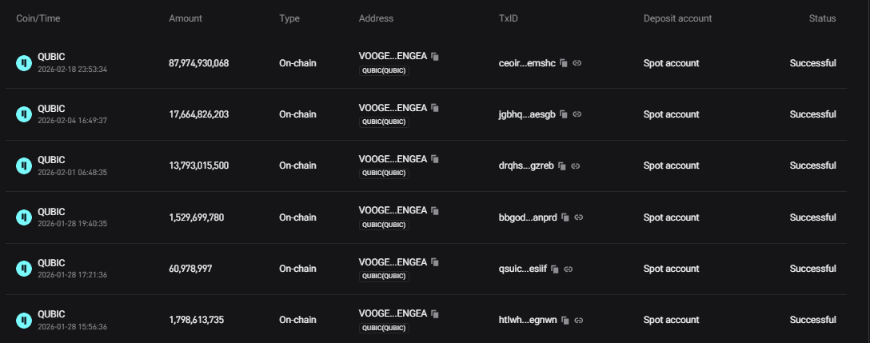

Balance of Wallet 3/11/2026 prior to $21186.79 increase
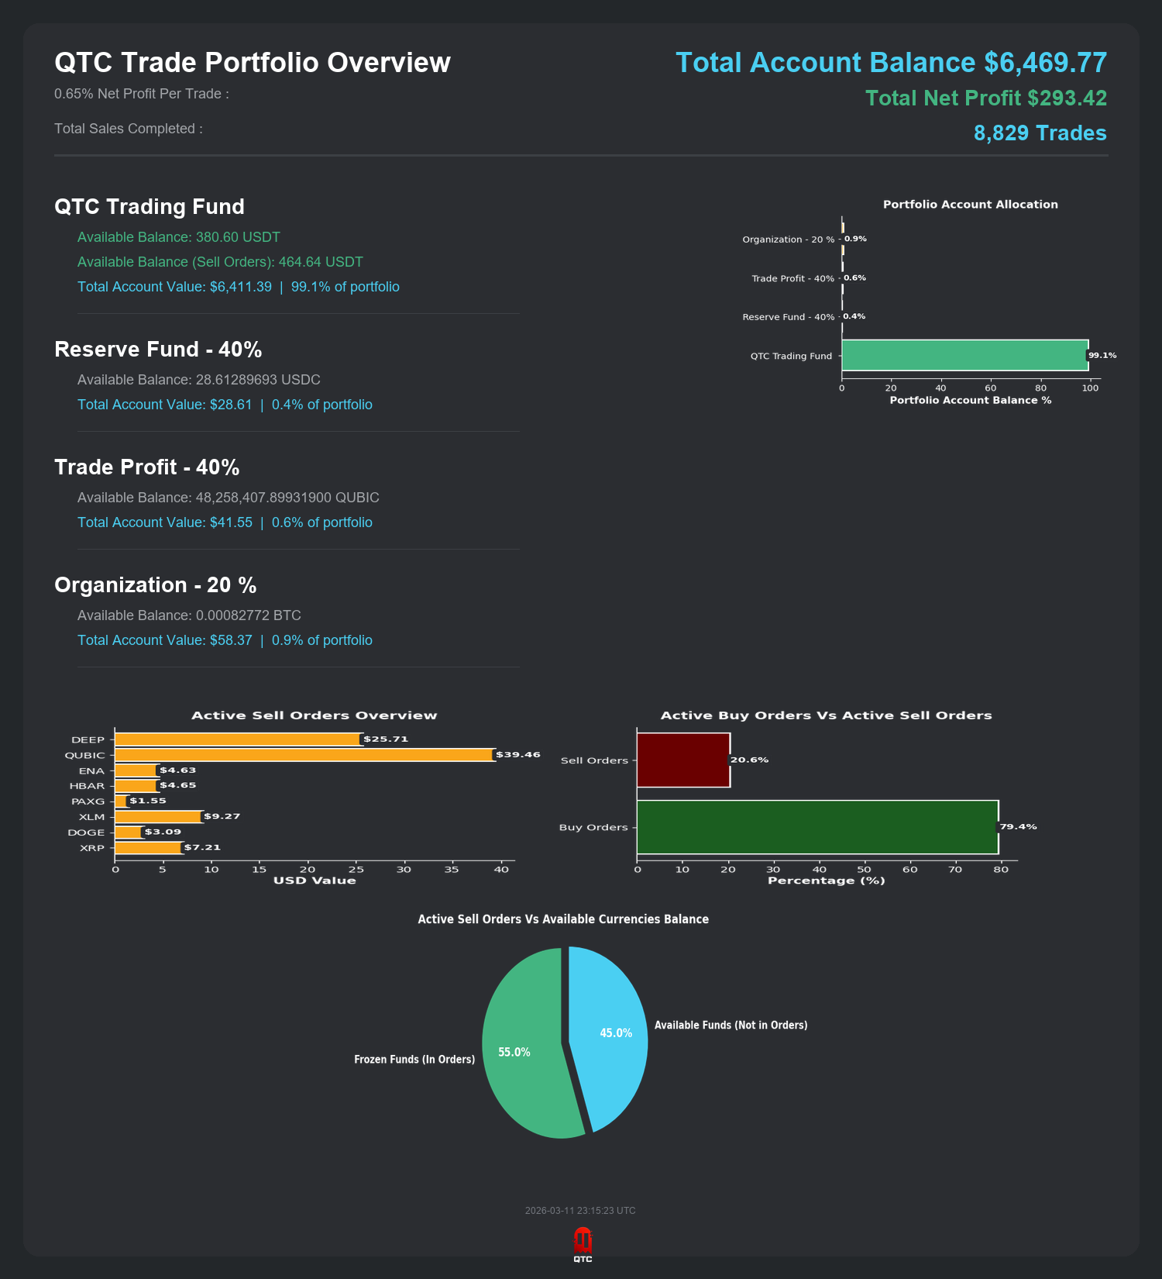

ICO SELLING PERCENTAGE | PRICE OF QUBIC |  | Amount Qubic Sold
122,822,064,283
5% Sold of the ICO | 0.000000800 | y | Qubic 6141103214  $4912.88
5% Sold of the ICO | 0.000000850 | y | Qubic 6141103214  $5219.93
10% Sold of the ICO | 0.000000900 | y | Qubic 12282206428  $11053.98
20% Sold of the ICO | 0.000001500 | n | 24564412856
20% Sold of the ICO | 0.000002000 | n | 24564412856
20% Sold of the ICO | 0.000003000 | n | 24564412856
20% Sold of the ICO | 0.000005000 | n | 24564412856

Total As Of 3/11/2026 $ 21186.79

4.3 Fund Allocation
Proceeds from the ICO will be allocated according to the following distribution model, designed to ensure operational sustainability, adequate reserves, and aggressive buyback operations:
Category | Allocation | Purpose
Bot Development & Operations | 20% | Infrastructure, maintenance, development costs, operational expenses
Bot Reserve Fund | 40% | Strategic reserves for bear market trading capacity and risk management
Buyback & Price Support | 40% | New buyback wall placements and continuous token acquisition

4.4 Post-ICO Operations
Following the completion of all ICO phases, the project will transition to continuous operations with ongoing buyback activities. The trading bot will continue generating profits, with all accumulated earnings directed toward QTC token acquisition and systematic burning, creating sustained deflationary pressure.

Token Burn Mechanics
Token Burn Policy: All QTC tokens acquired through buyback operations will be permanently removed from circulation by sending them to a verified burn wallet. This process reduces the total circulating supply over time, potentially increasing the scarcity and value of remaining tokens.
Burn Timing: Token burns will occur at strategically random intervals (not according to a fixed schedule) to maximize market impact and prevent predictability. This approach helps maintain positive market sentiment while ensuring efficient use of accumulated buyback funds.
Manual Burns: Qubic trade where exchange API functionality is unavailable, manual burn operations will be conducted to ensure continuity of the deflationary mechanism.

5. RISK FACTORS & IMPORTANT CONSIDERATIONS
Participation in the QTC project involves significant risks. Potential token holders must carefully evaluate the following risk factors before making any investment decision. This section outlines key risks but should not be considered exhaustive.

5.1 Market & Trading Risks
Cryptocurrency Market Volatility: Cryptocurrency markets are highly volatile and subject to rapid price fluctuations. While the QTC bot is designed to capitalize on volatility, extreme market conditions may result in reduced trading efficiency or temporary suspension of operations.
Prolonged Bear Markets: Extended downward price trends can significantly impact the bot's performance and require substantial reserves to maintain trading operations. During severe bear markets, profit generation may be substantially reduced or temporarily halted.
Liquidity Constraints: The Qubic network and associated trading pairs may experience periods of low liquidity, which can impact trade execution, increase slippage, and reduce overall profitability.
No Guaranteed Returns: Past performance of the trading algorithm is not indicative of future results. There is no guarantee that the bot will generate profits or that buyback operations will create sustained upward price pressure for QTC tokens.

5.2 Technical & Operational Risks
Exchange API Dependency: The bot's operations depend on continued API access provided by cryptocurrency exchanges (primarily Bitget). Changes to API functionality, rate limiting, or complete API discontinuation could significantly impact or halt trading operations.
Technical Failures: Software bugs, system failures, network outages, or other technical issues could result in trading errors, missed opportunities, or financial losses. While systems are designed with redundancy, no technology is completely immune to failure.
Algorithm Performance: The trading algorithm's performance may degrade over time as market dynamics evolve. Continuous development and adaptation are required, which may not always be successful.
Development Timeline: While the core trading bot is operational, full deployment of all planned features (including automated fund flows and comprehensive reporting) requires additional development time. Delays may occur.

5.3 Regulatory & Legal Risks
Regulatory Uncertainty: Cryptocurrency regulations are evolving globally and vary significantly by jurisdiction. Future regulatory changes could restrict operations, impose compliance burdens, or prohibit certain activities entirely.
Classification Risk: While QTC is intended as a service utility token, regulators in some jurisdictions may classify it as a security, which could impose additional legal requirements or restrictions.
Geographic Restrictions: The QTC offering may not be available to residents of certain countries due to local regulations. It is each participant's responsibility to ensure compliance with applicable laws.

5.4 Token-Specific Risks
No Refunds Policy: All QTC token purchases are final and non-refundable. This is a service offering, not a product purchase with return rights.
Limited Liquidity: QTC tokens may have limited liquidity, particularly during early phases. Token holders may not be able to sell their holdings quickly or at desired prices.
Price Volatility: QTC token prices may be subject to significant volatility due to market conditions, trading activity, sentiment shifts, and other factors beyond the project's control.
Project Discontinuation: In worst-case scenarios (such as prolonged inability to generate trading profits or insurmountable technical obstacles), the project may cease operations. In such cases, all remaining funds will be converted to Qubic and used to place buyback orders at the last ICO or post-ICO price levels.

5.5 Other Important Considerations
Qubic Smart Contract Risk: Any smart contracts used in the project may contain vulnerabilities or bugs that could result in loss of funds.
Team & Execution Risk: The project's success depends on the continued participation and performance of the development team. Key person dependencies exist.
Competition: Other trading bots, liquidity providers, and financial services may compete for the same opportunities, potentially reducing QTC's profitability.
Cybersecurity Threats: The project's infrastructure could be targeted by hackers or malicious actors, potentially resulting in theft of funds or disruption of operations.

5.6 Critical Reminder
DO YOUR OWN RESEARCH (DYOR) - Only invest funds you can afford to lose completely. Never invest borrowed money or funds needed for essential expenses. Cryptocurrency investments are speculative and high-risk. Seek advice from qualified financial, legal, and tax professionals before participating.

6. DEVELOPMENT ROADMAP
The QTC project follows a phased development and deployment strategy. The timeline below represents current estimates and may be adjusted based on market conditions, technical requirements, and community feedback.

6.1 Current Status (Q1 2026)
- Core trading algorithm completed and tested
- Basic fund management infrastructure operational
- Whitepaper published and community outreach initiated
- Discord community established

6.2 Phase 1: ICO Launch & Initial Operations (Q1-Q2 2026)
- Complete ICO Phase
- If there is any unsold QTC from the ICO , the remainder will be burned off the market
- Finalize automated fund flow between trading accounts
- Implement real-time Discord reporting system for transparency
- Launch community channels and begin regular progress updates

6.3 Post-ICO (Q2-Q4 2026)
- 100 % Burn of the QTC Token with Bot’s Profit (6 Months Test)
- Establishment of progressive buyback walls after each phase
- Continuous algorithm optimization based on market feedback
- Expansion of reserve fund to ensure multi-year operational capacity
- Enhancement of transparency tools and community engagement features

6.4 Post-ICO Operations (2027 and Beyond)
- Transition to fully automated continuous operations
- Regular token burn events to reduce circulating supply
- Potential expansion to additional Qubic-based trading pairs (subject to market conditions and profitability analysis)
- Development of advanced analytics and reporting dashboard for token holders
- Exploration of additional revenue streams and utility expansions within the Qubic ecosystem
Note: This roadmap represents current intentions and may be modified based on technical requirements, market conditions, regulatory developments, or other factors. The project prioritizes sustainable long-term operations over rapid but potentially unsustainable expansion.

7. FREQUENTLY ASKED QUESTIONS (FAQ)

General Questions

Q: What is QTC?
A: QTC (Quixotic Trading Organization) is a service utility token representing participation in an automated trading protocol operating on the Qubic network. The project utilizes a proprietary algorithmic trading bot to generate profits, which are used to systematically buy back and burn QTC tokens, creating deflationary pressure over time.

Q: How do I acquire QTC tokens?
A: QTC tokens are available for purchase through the phased Initial Coin Offering (ICO). The ICO consists of three phases with progressively increasing prices. Tokens will be available on Qubictrade . https://qubicico.com/ico/0

Q: Is QTC an airdrop or free distribution?
A: No. QTC is not distributed via airdrop or for free. All tokens must be acquired through the official ICO or secondary market purchases.

Trading Bot Questions

Q: How does the trading bot operate?
A: The bot continuously collects market data samples including price movements, volume, and volatility metrics. Based on this analysis, it determines optimal entry and exit points for trades. The system places multiple layered buy orders at strategic price levels and pairs each purchase with a sell order targeting approximately 0.9% gross profit (note of exchange Maker- , Taker Fees and Profit Loss at 0.05%). As market conditions change, the bot dynamically adjusts its parameters to optimize performance.

Q: Was this bot purchased from a third party?
A: No. The QTC trading system is entirely custom-developed and proprietary. It was built from scratch over several months specifically for Qubic network trading dynamics and represents a unique algorithmic approach not available from commercial bot providers.

Q: Does the bot guarantee profits?
A: No. While the bot is designed to operate profitably under most conditions, there are no guarantees. Performance depends on market volatility, liquidity, overall trend direction, and other factors beyond the system's control. Prolonged bear markets or extremely low volatility can significantly reduce profitability or result in temporary losses.

Q: Can I purchase or license the bot for personal use?
A: No. The trading bot is not for sale or licensing. It exists solely to operate the QTC buyback and burn mechanism. By holding QTC tokens, you indirectly benefit from the bot's performance without needing to manage the technical aspects yourself.

Q: Will the bot trade only during the ICO period?
A: No. The bot will continue trading indefinitely as long as exchange API access remains available and market conditions permit profitable operations. The ICO is only the token distribution phase; trading operations are designed to be perpetual.

Q: How does the bot increase its own wealth over time?
A: Yes, over time the bot will increase its own wealth like any investment. Reserves will be manually released over time to increase the bot's trading capacity and effectiveness as market conditions and project growth warrant strategic capital deployment.

Tokenomics & Buyback Questions

Q: How do buybacks work?
A: POST ICO the project establishes a buyback wall (large buy order) at a price of ICO phase 3 if the ICO sells at designated prices. These walls are funded exclusively from bot trading profits. Post-ICO, continuous buyback operations acquire QTC tokens from the open market using accumulated profits. All acquired tokens are permanently burned, reducing circulating supply.

Q: When do token burns occur?
A: Burns occur at strategically selected times rather than on a fixed schedule. This approach prevents predictability that could be exploited by traders and allows the project to maximize the market impact of each burn event. All burn transactions will be publicly verifiable on the blockchain and announced through community channels.

Q: Why not set buyback prices higher for faster price appreciation?
A: The buyback mechanism must be sustainable and realistic. Setting artificially high buyback prices would quickly exhaust available funds and undermine long-term project viability. The current structure prioritizes consistent, sustainable buyback operations over short-term price pumps that cannot be maintained.

Q: Is QTC going to moon?
A: QTC is a strategic buyback project with realistic expectations. While the deflationary mechanism and systematic buybacks create upward pressure on token value over time, cryptocurrency markets are volatile and unpredictable. The project makes no promises about specific price targets or timelines. Success depends on sustained bot profitability, favorable market conditions, and community support. Always maintain realistic expectations and never invest more than you can afford to lose.

Operations & Transparency Questions

Q: How can I verify the project's operations and fund movements?
A: The project maintains a dedicated Discord channel providing real-time updates on fund movements, trading performance, buyback operations, and token burns. All wallet addresses are publicly disclosed, allowing independent verification of transactions on the blockchain. Regular progress reports will be published to maintain community transparency.

Q: Why isn't this project running on Qubic's Discord infrastructure?
A: While the primary focus is on QTC and the Qubic ecosystem, the profit generation strategy may expand to include trading activities across multiple currencies and platforms to maximize returns. Regardless of which assets generate the profits, all buyback operations will be conducted exclusively for QTC tokens. This multi-asset approach provides flexibility and reduces dependence on any single market or trading pair.

Risk & Policy Questions

Q: Can I return or refund my QTC tokens?
A: No. All QTC purchases are final and non-refundable. This is a service utility offering, not a traditional product with return rights. Once tokens are acquired, the transaction is permanent. Only trading profits generated by the bot will be used for buyback operations—there is no mechanism for direct refunds to token holders.

Q: What happens if the project fails or must discontinue operations?
A: In the worst-case scenario where the project cannot continue (such as prolonged inability to generate profits, insurmountable technical obstacles, or regulatory prohibition), all remaining funds will be converted to Qubic at market prices and used to place buyback orders at the last completed ICO or post-ICO price level. This provides a final liquidity option for token holders, though there is no guarantee of full capital recovery.

Q: How long might the full buyback process take?
A: The timeframe for completing buyback operations depends entirely on market conditions, bot profitability, and token supply dynamics. This is fundamentally a long-term project that may take multiple years to reach full operational maturity and complete substantial supply reduction. Token holders should approach QTC with patience and realistic expectations about the timeline for value appreciation.

Q: What are the main risks I should be aware of?
A: Key risks include cryptocurrency market volatility, prolonged bear markets reducing bot profitability, exchange API changes or discontinuation, technical failures, regulatory changes affecting operations, limited token liquidity, and the possibility of complete capital loss. Refer to Section 5 (Risk Factors) of this whitepaper for comprehensive risk disclosures. Always conduct thorough research and consult with qualified advisors before investing.

8. LEGAL DISCLAIMER & TERMS

8.1 No Investment Advice
This whitepaper is provided for informational purposes only and does not constitute financial, investment, legal, or tax advice. You should not interpret any information contained herein as a solicitation to purchase QTC tokens or any other financial instruments. The information presented is not tailored to your specific financial situation, investment objectives, or risk tolerance.
Before making any investment decision, you must conduct your own due diligence and consult with qualified financial advisors, legal counsel, and tax professionals familiar with cryptocurrency investments and your specific jurisdiction's regulations.

8.2 Forward-Looking Statements
This whitepaper contains forward-looking statements regarding future events, projections, expectations, and plans. These statements are subject to significant risks, uncertainties, and assumptions that may cause actual results to differ materially from those expressed or implied. Forward-looking statements include but are not limited to:
- Projected trading bot performance and profitability
- Anticipated token buyback volumes and timing
- Development roadmap timelines and feature completion
- Market conditions and trading environment assumptions
- Expected regulatory treatment and compliance approaches
The QTC team undertakes no obligation to update forward-looking statements as circumstances change or new information becomes available. Do not place undue reliance on such statements.

8.3 No Guarantees or Representations
Quixotic Trading Organization makes no guarantees, warranties, or representations regarding:
- The profitability or performance of the trading bot under any market conditions
- The future value, liquidity, or marketability of QTC tokens
- The successful completion of all development roadmap items
- The continued availability of exchange APIs or trading infrastructure
- The accuracy, completeness, or reliability of information in this whitepaper
- The regulatory status or legal treatment of QTC in any jurisdiction

8.4 Regulatory Compliance
Cryptocurrency regulations vary significantly across jurisdictions and are subject to rapid change. It is solely your responsibility to determine whether your participation in the QTC project complies with applicable laws and regulations in your jurisdiction. The QTC project may not be available to residents of certain countries due to regulatory restrictions.
By acquiring QTC tokens, you represent and warrant that: (1) you have the legal capacity and authority to participate, (2) your participation does not violate any applicable laws or regulations, (3) you are not a resident of a prohibited jurisdiction, and (4) you understand and accept all associated risks.

8.5 Limitation of Liability
To the maximum extent permitted by applicable law, Quixotic Trading Organization, its developers, team members, advisors, and affiliates shall not be liable for any direct, indirect, incidental, special, consequential, or punitive damages arising from:
- Acquisition, holding, or disposal of QTC tokens
- Use of or reliance on information contained in this whitepaper
- Technical failures, security breaches, or operational disruptions
- Losses incurred through trading bot operations or market movements
- Changes in regulatory treatment or legal requirements
- Inability to complete planned development or operational objectives

8.6 Modification and Updates
Quixotic Trading Organization reserves the right to modify, update, or replace any aspect of this whitepaper, the project roadmap, tokenomics structure, or operational procedures at any time without prior notice. Such modifications may be necessary to address technical requirements, regulatory changes, market conditions, or other unforeseen circumstances.
Updated versions of this whitepaper will be published through official channels. Token holders are responsible for staying informed about project developments and updates.

8.7 Final Acknowledgment
BY ACQUIRING QTC TOKENS, YOU ACKNOWLEDGE THAT:
- You have read, understood, and agree to all terms and conditions outlined in this whitepaper
- You understand that cryptocurrency investments carry substantial risk of complete capital loss
- You have conducted your own independent research and due diligence
- You are investing only funds you can afford to lose completely
- You accept all risks associated with the project and will not hold the QTC team liable for any losses
- You understand that QTC tokens are non-refundable service utility tokens, not securities or investment contracts
- You have verified compliance with all applicable laws in your jurisdiction
REMEMBER: DO YOUR OWN RESEARCH. NEVER INVEST MORE THAN YOU CAN AFFORD TO LOSE.

***
For the latest updates and community discussions:
Join our Discord: https://discord.gg/2NGfYds2Pm
Developer Support Address
APOJSDOROSZDVDOKBXLCDLNBBVFCMTHRQRLXFJVGUCSBMZQKMELPIHXARWIN
(Optional contributions to support ongoing development)

